EXPERIMENT: 4
DML Commands with Constraints –UPDATE, DELETE

Aim:
To perform Data Manipulation Language (DML) Commands such as UPDATE, DELETE in the table.
Description:
Data Manipulation Language (DML) statements are used for managing data within schema objects. DML
Commands: Update, Delete
➢ UPDATE - updates existing data within a table
➢ DELETE - deletes all records from a table, the space for the records remain
UPDATE:
UPDATE table_name
SET column1=value, column2=value2,...
WHERE some_column=some_value;
DELETE:
DELETE FROM table_name
WHERE some_column=some_value;

Questions:
1. Update the value of student name whose register number is ‘191711342’
2. Delete the record in the table FACULTY, who resigned her job.
3. Modify the age for the faculty whose name is 'mohan' with a value ‘59’.
4. Remove all faculty who are having over 65 years

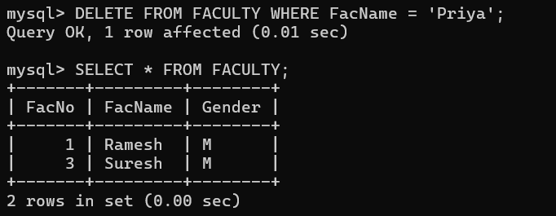
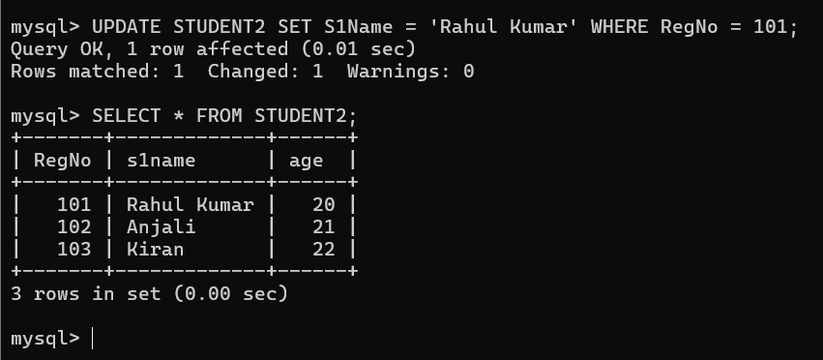
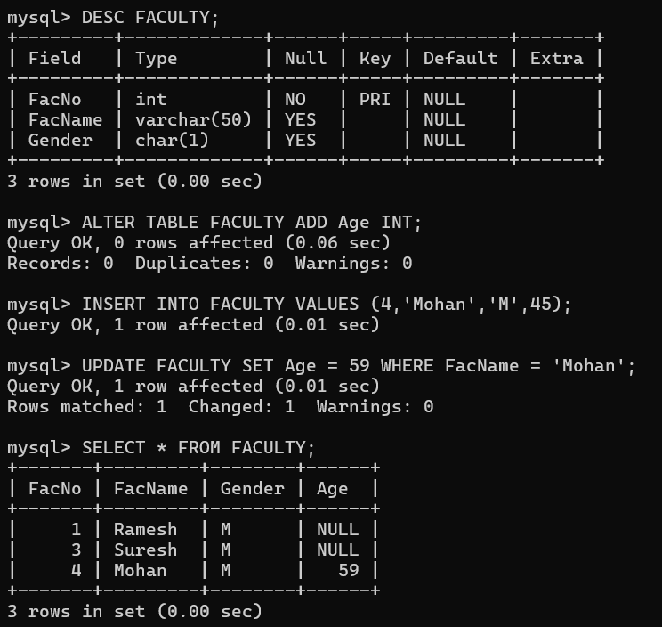
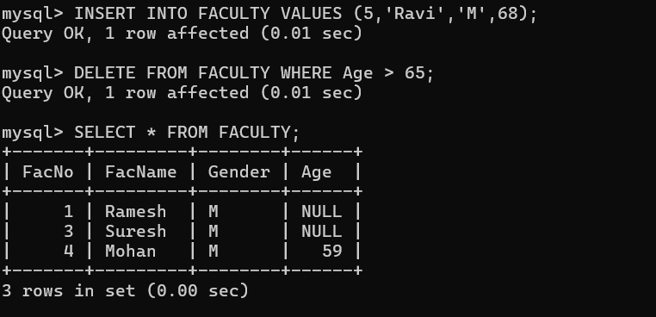

RESULT
Data Manipulation Language (DML) commands such as UPDATE and DELETE were successfully performed on the tables.

